Multi- purpose forming system for strengthening structural elements of buildings and works
S.G. Abramyan^{1, a *}, O.V. Burlachenko^{1, b} and O.V. Oganesyan^{1, c}
¹Institute of Architecture and Civil Engineering of Volgograd State Technical University, 1 Akademicheskaya str., Volgograd, 400074, Russia
ªsusannagrant@mail.ru*, ^{b}oburlachenko@yandex.ru, ^{c}ogoganesyan@mail.ru
Keywords: "Transformer" forming system, technological intensity, high reusability, multi-functionality, composite materials.

Abstract. The authors suggest a new forming system designed for strengthening certain structural elements, by means of widening, for the purpose of reconstruction of buildings and works. A prefabricated “transformer” decking is a versatile forming system, which can be arranged both as a three-dimensional closed P-structure and as a flat structure, depending on the purpose or type of a specific structural element to be strengthened and the work method to be employed. It is also technology intensive, requiring approximately 3-4 times less labor effort as compared to conventional small-panel forms used for reconstruction and overhaul of construction systems. The newly developed forming system is consistent with the environmental safety requirements, having a deck made of porous artificial wood instead of natural wood, as was previously substantiated by the authors’ calculations. Because porous artificial wood, having all the benefits of natural wood (i.e. ease of processing), is free of its drawbacks, a “transformer” form is flameproof and moisture resistant. Enhanced usability of such a forming system is achieved through the use of a material reliable in operation and easy for processing.
Introduction
The relevance of the selected topic is associated with an increasing scope of reconstruction of buildings and works, being one of the main aspects of sustainable development of urban space [1-3] and provision of housing [4-6] for urban population. The rationality and comfort of municipal and any other residential environment are a function of improved performance parameters (also accomplished through overhaul) and enhanced operational and environmental safety of existing buildings and works [7,8].
The reconstruction and overhaul of buildings and works involve the strengthening or rehabilitation of their main load-bearing structural elements: foundations, columns, walls etc. [9].
One of the key strengthening methods as part of building reconstruction is the widening (increase of cross-section and accordingly, volume) of underlying structural elements (pier foundations, columns, beams etc.), in particular, by building a concrete collar or jacket. The conventional work methods employ forming systems or concrete spraying techniques. Although there are various innovative methods for strengthening building structures without the use of forming systems, and recent years have seen an active development of permanent forms made of composite materials [10-16], conventional forming systems are still popular in terms of strengthening various structural elements as part of reconstruction and overhaul of construction systems.
The analysis of publications [17-21] shows that the development and improvement methods are mainly focused on forming systems used for building new properties, where a form, being a permanent structure, often becomes a part of the structural elements to be erected. This approach allows reducing labor input in construction, improve the quality of construction works and cut down construction costs. Apart from permanent forms, cast-in-situ structures of new properties use various highly reusable prefabricated forms, while reconstruction and overhaul projects use small-panel wooden forms arranged immediately on the construction site. Installation and dismantling of such forms increase the cost of overhaul and reconstruction, and give a 10-15 % rise in the consumption of wood.

Goal, tasks, methods of study
The goal of this work is to develop a new highly reusable transformer decking, experimentally substantiate its use for strengthening of pier foundations and columns, as well as for reconstruction and overhaul of retaining walls.
To achieve this goal, the following tasks were completed: boosting technology intensity by reducing the number of process operations as part of form installation and dismantling; making the forming system highly reusable through the adoption of materials which are reliable in operation, easy for processing, relatively low-weight, and so on.
Considering that the modern forming systems used to strengthen structural elements are most commonly made of expensive materials (wood, metal) and should be replaced with their more economical counterparts, a hypothesis arose featuring artificial wood as the decking (board) material for the suggested transformer decking. Previously, the need for use of innovative technologies in the reconstruction of buildings and works was dicussed by the authors in [9, 22].
The principal methods and means for meeting the task (subject matter) of the study are the analysis and comparison of various forming systems of domestic and foreign manufacturers used for erection and strengthening of columns and walls, together with the building of an imitation model of a transformer decking and its experimental substantiation.
The practical value of the study consists in the application of its results for the purpose of strengthening building structures by way of widening, with minimum labor input.
Design of new forming system
The framing of the forming system consists of wooden bars with dimensions of 40 х 100 mm, pair-wise connected by piano hinges (figure 1 shows regular wooden hinges instead of piano hinges). This connection method allows for arranging the main (framing) bars of a forming system at an angle of 90⁰ against each other (Γ-shaped arrangement), or stretching them out in a flat configuration. A forming system for strengthening columns (by means of widening to increase their cross-section) is assembled by securing Π-shaped metallic brackets on the four sides of the system framing. The brackets are closed from below and interconnected by planks (refer with: Fig.1).

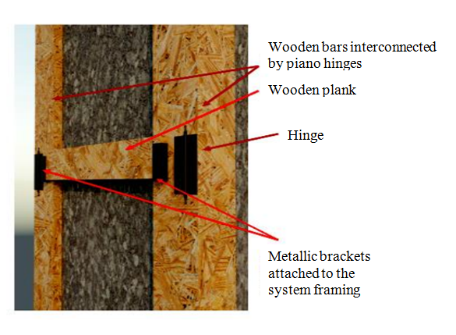
Fig. 1. Design of a forming system without a board
The planks placed in the metallic brackets, which are mounted at a certain interval, ensure rigidity of the forming system, where the brackets must always be secured at the lower and upper ends of the system framing. The width of a plank depends on its length, and the number of planks depends on the interval between the brackets. To provide the necessary column diameter, plastic blocks are mounted on the inner side of the Γ-shaped elements, and at the lower and upper ends. The blocks are screwed onto dowels provided in the Γ-shaped elements and have a length determined according to the thickness of the element to be widended. The decking is placed so as to seat in the framing grooves (refer with: Fig.2).

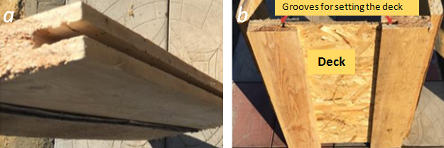
Fig. 2. General view of the framing element (a), setting the deck in framing grooves (b)

Figure 3 shows the deck cross-section, where the dimensions of the part marked by red circle correspond to the framing grooves.
Fig. 3. Deck cross-section
Due to the projecting part, the deck forms a smooth surface leveled with the framing. The general view and stage-wise assembly of the form sections are illustrated in figure 4.
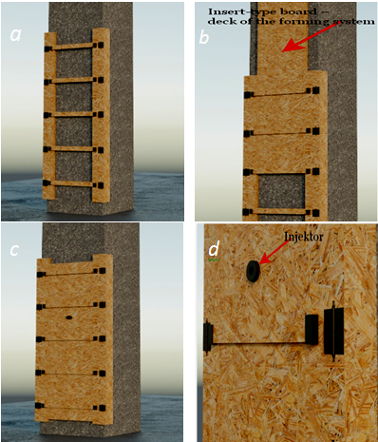
Fig. 4. Assembly of the forming system: a – framing assembly; b – deck mounting; c – part of the forming system with the deck set in place; d – as-assembled forming system

Figure 5 shows a forming system used for strengthening walls, including retaining walls, transformed into a flat arrangement.

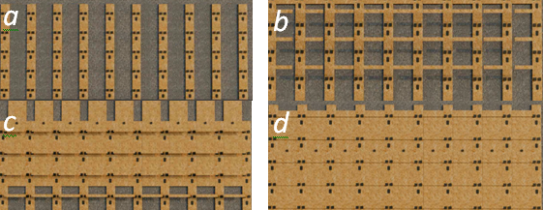

Fig. 5. Flat arrangement of the forming system: a – assembly of the main framing elements; b – securing by planks; c – setting the boards in grooves; d – ready-for-use forming system
Experimental part
The experimental part was completed to determine the technology intensity of the suggested forming system, i.e. the amount of labor involved in its installation and dismantling. The deck was made of an oriented strand board (OSB) sheet with suitable dimensions. The labor input involved in the preliminary assembly of the forming system, as well as its installation on the site for widening a structural element (in this case, a column) and subsequent dismantling, was lower, albeit insignificantly, than for conventional forming systems used for strengthening (widening) of building structures (refer with: Fig. 6).
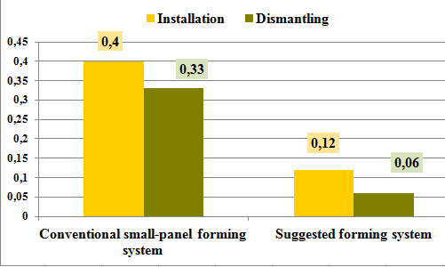
Fig. 6. Installation and dismantling labor input for conventional forms and the new form, man/h/m²

As such, one technological solution is accomplished, although as experience shows existing large-panel forming systems can be adapted to increase the cross-section of structural elements (columns, pier foundations, beams etc.) for the purpose of building reconstruction. A second technological solution stems from the ability of a forming system to easily transform into a flat arrangement. The versatility of the forming system is associated with its potential arrangement as a steel-concrete shell used for building reconstruction.
For saving natural wood, the deck of the suggested forming system can be made of Vinyzol porous artificial wood (PID-IV) developed by the Irkutsk scientists [23]. The design analysis [24] helped prove that Vinyzol, including all its technical characteristics, is suitable as a deck material for the suggested structural pattern.
Summary
The new forming system meets the recent requirements for technology intensity, as it requires minimum labor input for installation and dismantling. It is also versatile, as it can be used for strengthening various structural elements (by way of their widening) and creating steel-concrete shells as part of building reconstruction. The forming system can be configured both as a three-dimensional closed P-structure and as a flat structure, depending on the purpose or type of a structural element to be strengthened and the work method.
A transformer decking meets the environmental safety requirements as follows:
- Porous artificial wood can be used instead of natural wood as substantiated by the design analysis.
- Porous artificial wood, having all the benefits of natural wood (easy for processing with carpenter tools), at the same time lacks its drawbacks. As a result, the suggested forming system is flameproof, moisture resistant, and more resistant to various chemical impacts.
It is important to note that PID-IV is made of two types of solid industrial waste – organic and mineral (TPP carryover ash), and industrial waste is less contaminated than domestic waste.As compared to existing forming systems, the suggested system has a lower cost because porous artificial wood is produced domestically.
The novelty of this work consists in offering a transformer type decking which is technology intensive, versatile, economical and made of a material capable of replacing natural wood. The latter eventually ensures the maintenance of balance in the natural environment. The theoretical importance of this paper lies in the fact that it can be used as a basis for the development of new forming systems. The practical importance is delivered by the solutions offered for overhaul and strengthening of structural elements at the lowest cost.
References
[1] S.G. Abramyan, O.V. Oganesyan, Sustainable Development and Ecological Safety of Construction of Buildings and Facilities: Technogenic Factors Influencing the Atmosphere. Part I, Bulletin of IACE of VSTU: Construction and Architecture. 42(61) (2015) 202-210. (In Russian)
[2] S.G. Abramyan, Construction industry and sustainable development concept, Internet magazine Science Studies (Naukovedeniye). 9(5) (2017). URL: https://naukovedenie.ru/PDF/64EAVN517.pdf. (In Russian)
[3] S.G. Abramyan, O.V. Oganesyan, The definition of «the reconstruction of buildings and structures» in the existing regulations, International scientific review. 14 (2016) 49-52. (In Russian)
[4] K. Lee, C. Park, The Sustainable Micro-Scale Movement of Communities: Case Studies of Subdivided Development and Adaptive Reuse of Shared Space in New York City, Journal of Green Building. 11(1) (2016) 23-27.
[5] D.V. Kovalyov, V.G Chudinova, Reconstruction and Modernization of Residential Environment of Large Panel Buildings of The Large-Scale Series, Bulletin of SUSU: Construction and Architecture. 1 (2013) 4-8 (2013) (In Russian)
[6] I.Yu. Zil'berova, K.S. Petrov, Problems of reconstruction of residential buildings belonging to various construction periods, Engineering Journal of Don. 4-1 (2012). URL: ivdon.ru/uploads/article/pdf/148.pdf_1119.pdf (In Russian)
[7] S.G. Abramyan, R. Kh. Ishmametov, Strengthening Timber Roof Trusses During Building Construction and Reconstruction, Procedia Engineering. 150 (2016) 2133-2137.
[8] S.G. Abramyan, Environmental Compliance during Construction, Procedia Engineering. 150 (2016) 2146–2149.
[9] S.G. Abramyan, V. G. Polyakov, O.V. Oganesyan, Pneumatic formwork used in strengthening of structural elements during reconstruction of buildings and structures, MATEC Web of Conferences. 129 (2017) 05001.
[10] G.M. Bad'in, S.A. Sychev, Modern Building Construction and Reconstruction Technologies, St. Petersburg, 2013. (In Russian)
[11] E.L. Ayrumyan, I.A. Rumyantseva, Reinforcement of a Monolithic Concrete Floor Slab Using a Profiled Steel Deck, Industrial and Civil construction. 4 (2007) 25-27. (In Russian)
[12] R. S. Fedjuk, Axle Solid Concrete Wall Using Permanent Formwort of Polystyrene Foam, Bulletine of RUDN, Series: Enig Surveys. 4 (2013) 105-114. (In Russian)
[13] S.S. Zimin, N.S. Alekseev, Constructive and technological solutions of three-demensional reinforcing block with fixed bearing timbering from fibrous concreate, Modern scientific researches and innovations, 11(55) (2015) 193-203. (In Russian)
[14] D. Lau, QW Qiu, A. Zhou, CL Chow, Long term performance and fire safety aspect of FRP composites used in building structures, Construction and building materials. 126 (2016) 573-585.
[15] XY Xiong, ZY Su, Experimental study and theoretical analysis of carbon fibre-reinforced polymer strengthening timber pier column, Materials Research Innovations, 19 (2015) 1246-1254.
[16] J. Garbett, AP Darby, TJ Ibell, Optimised Beam Design Using Innovative Fabric-Formed Concrete, Advances in Structural Engineering. 13 (5) (2010) 849-860.
[17] B. Yoo, H. Yoon, Y. Kim, K. Lee, Stepwise Application of BIM-based Parametric Modeling to Tapered Slip-Form System, Procedia Engineering. 145 (2016) 112-119.
[18] J. Gong, XA Wang, YL Huang, CK Zhao, The research progress on structure design calculation method of integral climbing steel platform formwork equipment, Fundamental Research in Structural Engineering: Retrospective and Prospective, 1 and 2, (2016) 1327-1337.
[19] A. Krawczynska-Piechna, Comprehensive Approach to Efficient Planning of Formwork Utilization on the Construction Site, Procedia Engineering. 182 (2017) 366-372.
[20] K. Wang, XT Wang, M. Qu, XD Chen, Mechanical Analysis And Optimum Design of Universal Panel Construction Formwork System, Applied Mechanics and Materials. 37-38 (2011) 628-633.
[21] JZ Zhou, Q. Lin, MP Liao, JP Zhuang, XF Cai, Application of Modularized Low-position Jacking Formwork System in Core-tube Building, Applied Mechanics and Materials, 405 (2013) 3103-+.
[22] S.G. Abramyan, O.V. Oganesyan, Polymer-Bitumen Binder Based Multifunctional Material, Solid State Phenomena, 265 (2017) 303-307.
[23] E.O. Kostjukova, E.O. Zelinskaja, V.V. Barahtenko, F.A. Shutov, Technology of production of an innovative construction material – porous artificial wood (Vinizol) in the Irkutsk Region, Modern Knowledge Intensive Technologies. 8 (2010) 162-165. (In Russian)
[24] S.G. Abramyan, O.V. Oganesyan, A.S. Abraamyan, Making formwork systems of porous artificial wood, Engineering Journal of Don. 4 (2017). Information on: ivdon.ru/uploads/article/pdf/IVD_29_Abramian.pdf_e22959c78e.pdf (In Russian)

