The influence of modification by superdispersed powders on the lead-tin-base bronze structure
S V Petrov¹, N S Sidorov¹, A A Vorohov²

¹ Tomsk Polytechnic University, 30, Lenina ave., Tomsk, 634050, Russia
² Novosibirsk State Technical University, 20, Karla Marks ave., Novosibirsk, 630073, Russia

E-mail: Petrov@mail.ru

Abstract. The paper presents data on the influence of additives of the pre-treated aluminium oxide powder on the structure of cast lead-tin-based bronzes. Different quantities of the modifier, based on the superdispersed aluminum oxide powder, were added to the bronze melt. The studies have shown that addition of a small amount of aluminum oxide powder (0.07…0.25 %) allows modifying the microstructure of the obtained castings. This modification includes grain refinement, reduction of the matrix dendrites size of tin solid solution in copper, as well as formation of spherical inclusions of the low-melting phase – lead. In this case, the addition of such modifier influences weakly the morphology and the quantity of solid eutectoid inclusions based on electron compound Cu₃₁Sn₈.
Keywords:
- Introduction
In the modern mechanical engineering a significant number of parts are fabricated from lead-tin-base bronzes. They include a series of parts which should possess sufficiently advanced strength characteristics (sealings and piston rings, oil-seal and expander rings). In order to enhance tribotechnical characteristics, lead is introduced into these materials. Lead reduces friction coefficient, enhances tribotechnical characteristics, however, it reduces strength significantly.
At present one of the promising trends of enhancing a set of service properties of such bronzes is alloying them with superdispersed powders (SDP). Introduction of their small amount into the melt before a crystallization process allows increasing strength propeties of castings [1, 2]. But a mechanism of interaction with lead-tin-based bronzes, as well as the process regularities of such modification, is not studied profoundly. However, such modification of copper alloys is promising from several points of view.
This paper presents an investigation of the influence of different content of additives of the pre-treated aluminium oxide powder on the structure of lead-tin-base bronze under formation.
- Materials and methods
The lead-tin-base bronze of the BrO10S10 grade (Russian grade abbreviation) was used as a material for investigation. This bronze contains 10 % wt. of lead, 10 % wt. of tin and 80 % wt. of copper. The multicomponent bronzes under study were melted in the induction high-frequency furnace in crucibles. The crucibles’ material is silicicated graphite. Melting was conducted using the components of technical grade. Cathode copper of the Mlk grade (GOST 859-78), sheet lead of the C-2 grade (GOST 3778-77); rod tin of the O1 grade (GOST 860-75) were used as a charge mixture. The phosphorous-copper alloy of the MF1B grade (GOST 4515-93) was used as a deoxidizer. The preliminarily placed in the copper foil powder-modifier was introduced into the melt.
The aluminum oxide powder, being wrapped into the copper foil, was introduced into the bronze melt after its treatment in the copper powder mixture in the ball planetary-type mill. The method of powder treatment is described in [3, 4]. The pouring was realised into the graphite moulds at room temperature. The content of the powder was 0.07; 0.15; 0.25; 0.5; 0.75 and 1.5 % wt.
- The study of the structure of the modified lead-tin-base bronze
Reasoning from theoretical premises, the main consequence of nanopowder introduction into the melt should be refinement of the macro- and microstructure, as the powder particles must serve as nuclei of new grains. Figures 1 and 2 show photos of the microstructure of cast samples from the bronze of the lead-tin bronze grade, both modified by SDP of aluminium oxide and without modifier addition. The phase composition of the bronze under study represented in photos of the microstructure is a solid solution of tin in copper, lead inclusions and eutectoid inclusions based on electron compound.
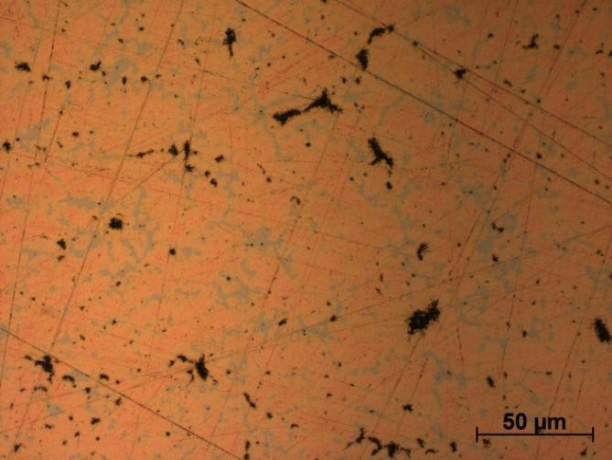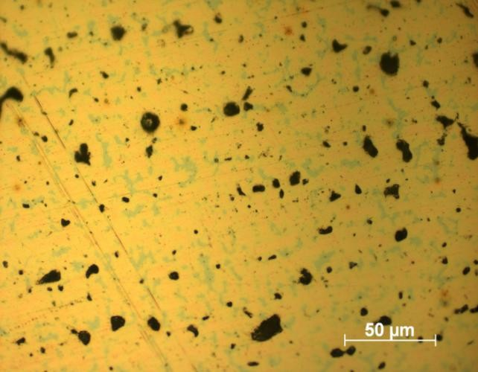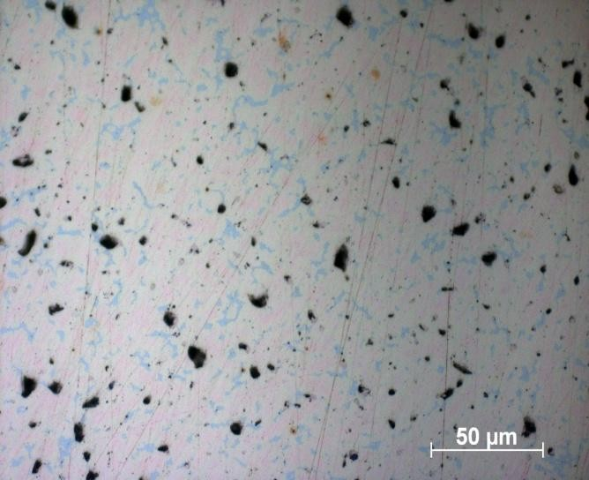
a b c
Figure 1. A microstructure of BrO10S10 bronze castings with different content of the alloying additive of the Al₂O₃ powder: a – without the powder; b – 0.07 % of the Al₂O₃ powder; c – 0.75 % of the Al₂O₃ powder.

As it is seen from Figures 1 and 2, as a result of modification of crystallization conditions, a different morphology of inclusions of the low-melting phase and eutectic inclusions in the castings is formed. In addition, from the studies conducted earlier [3], it is known that the cooling rate influences considerably both the shape and the quantity of eutectoid under formation. The higher is the cooling rate, the less amount of eutectoid is formed.
Figures 1 and 2 show that when introducing a small amount (0.25 %) of the aluminium oxide powder, there is a 2.5 time decrease of the distance between the dendrites axes of the second order, and a ~ 1.5 time decrease of the grain size. This implies that a considerable amount of powder particles served as effective crystallization centres. When increasing the content of SDP of Al₂O₃, the structure started to coarsen relatively that which was obtained, using low concentrations of the powder. With its 1.5% perscentage, the differences of its structure from the unmodified one are insignificant. This is connected with coagulation of the powder particles in case of the sufficiently high (>0.5 wt. %) powder concentrations. It is necessary to note that the microstructure refinement was homogeneous throughout the casting volume, which indirectly implies that the modifer distribution was also homogeneous enough and it had not floated to the casting surface.

Table 1. Dependence of the sphericity coefficient of lead inclusions and average sizes of bronze lead inclusions on the modifier concentration
Al₂O₃ powder content, % | Sphericity coefficient of lead inclusions | Average size of lead inclusions, µm | Eutectoid content, % | Sphericity coefficient of (α+δ) eutectoid inclusions | Average size of (α+δ) eutectoid inclusions, µm
0 | 10.2 | 6.9 | 15 | - | -
0.07 | 2.2 | 5.1 | 13 | 8.2 | 20.1
0.15 | 2.8 | 7.3 | 12 | 9.1 | 21.8
0.25 | 2.6 | 9.3 | 14 | 11.3 | 16.7
0.5 | 3.5 | 9.5 | 13 | 12.7 | 18.6
0.75 | 4.1 | 15.8 | 10 | - | -
1.5 | 6.9 | 18.2 | 13 | - | -

The qualitative analysis of the cast samples’ structures has shown that we have not succeeded in detecting a significant difference in the eutectoid amount under various concentration of the modifier. By means of the metallographic studies it has been found that the change in the eutectoid content is not so significant as it was during the influence of different cooling rates on the same bronze. The maximal difference (a decrease from 15 % to 10 %) was detected in case of the sample, which contained 0.75 % of the modifier. At that, the samples with 0.75 and 1.5 % addition of the modifier possessed such vastly branching morphology of eutectoid that it did not allow determining a spericity coefficient and an average size for them.
- Conclusion
After conducted studies of the lead-tin-base bronze structure of the BrO10S10 grade, it is possible to conclude that the modification with superdispersed powders influences considerably its structure. It is particularly typical for low concentrations of the modifier (up to 0.25 %).
When introducing a small amount of the aluminium oxide powder, the distance between the axes of the second-order dendrites and the average grain size reduces. This implies that a considerable part of the powder particles is effective crystallization centres. When increasing the nanopowder content, the structure starts coarsening relatively that, which was obtained using low powder concentrations. Introduction of the large quantity of the modifier leads to its coagulation and reduction of its influence on the structure.
Acknowledgments
The reported study was funded by the Russian Humanitarian Science Foundation (RHSF 16-16-70006) and RFBR, according to the research project No. 16-38-60146 mol_a_dk.
References
- Oh J C, Yun E, Golkovski M G and Lee S 2003 Mater. Sci. Eng. A 351 98-108
- Yilbas B S, Patel F and Karatas C 2015 Laser Surface Engineering Waugh J.L.G. Woodhead Publishing 97-105
- Stepanova N V, Razumakov A A 2013 The 8 international forum on strategic technologies (IFOST 2013) 1 240–242
- Rogachev A S, Shkodich N F, Vadchenko S G, Baras F, Chassagnon R, Sachkova N V, and Boyarchenko O D 2013 Int. J. Self-Propag. High-Temp. Synth. 22(4) 210–216
- Bataev I A, Bataev A A, Mali V I, Pavliukova D V 2012 Materials and Design 35 225–234
- Bernard F and Gaffet E 2001 Int. J. Self-Propag. High-Temp. Synth. 10(2) 109–132

